## **Objectives**

* Explain various ways of conditional rendering
* Explain how to render multiple components
* Define list component
* Explain about keys in React applications
* Explain how to extract components with keys
* Explain React Map, map() function

In this hands-on lab, you will learn how to:

* Implement conditional rendering in React applications

## **Prerequisites**

The following is required to complete this hands-on lab:

* Node.js
* NPM
* Visual Studio Code

## **Notes**

Estimated time to complete this lab: **60 minutes.**

Create a React App named “bloggerapp” in with 3 components.

1. Book Details
2. Blog Details
3. Course Details

Implement this with as many ways possible of Conditional Rendering.

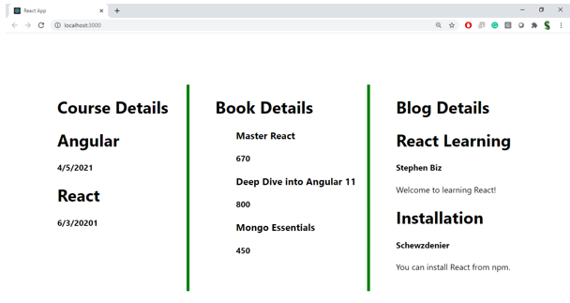

**Hint:**

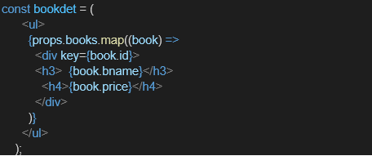

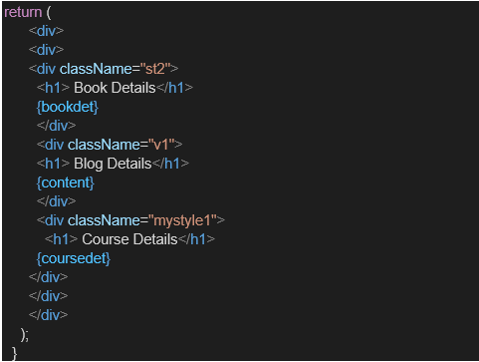

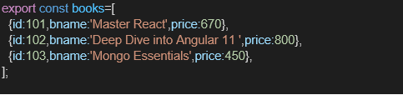

**App.js**

import React from 'react';

import CourseDetails from './CourseDetails';

import BookDetails from './BookDetails';

import BlogDetails from './Blogdetails'; // again, match the actual filename

import './App.css';

function App() {

  return (

    <div className="container">

      <CourseDetails />

      <BookDetails />

      <BlogDetails />

    </div>

  );

} export default App

**Blogdetails.js**

import React from 'react';

function BlogDetails() {

  const blogs = [

    {

      title: "React Learning",

      author: "Stephen Biz",

      desc: "Welcome to learning React!"

    },

    {

      title: "Installation",

      author: "Schwezdenier",

      desc: "You can install React from npm."

    }

  ];

  return (

    <div className="box">

      <h2>Blog Details</h2>

      {blogs.map((blog, index) => (

        <div key={index}>

          <h3>{blog.title}</h3>

          <p><strong>{blog.author}</strong></p>

          <p>{blog.desc}</p>

        </div>

      ))}

    </div>

  );

}

export default BlogDetails;

**BookDetails.js**

import React from 'react';

function BlogDetails() {

  const blogs = [

    {

      title: "React Learning",

      author: "Stephen Biz",

      desc: "Welcome to learning React!"

    },

    {

      title: "Installation",

      author: "Schwezdenier",

      desc: "You can install React from npm."

    }

  ];

  return (

    <div className="box">

      <h2>Blog Details</h2>

      {blogs.map((blog, index) => (

        <div key={index}>

          <h3>{blog.title}</h3>

          <p><strong>{blog.author}</strong></p>

          <p>{blog.desc}</p>

        </div>

      ))}

    </div>

  );

}

export default BlogDetails;

**CourseDetails.js**

import React from 'react';

function CourseDetails() {

  const courses = [

    { name: "Angular", date: "4/5/2021" },

    { name: "React", date: "6/3/2021" }

  ];

  return (

    <div className="box">

      <h2>Course Details</h2>

      {courses.map((course, index) => (

        <div key={index}>

          <h3>{course.name}</h3>

          <p>{course.date}</p>

        </div>

      ))}

    </div>

  );

}

export default CourseDetails;

**App.js**

import React from 'react';

import CourseDetails from './CourseDetails';

import BookDetails from './BookDetails';

import BlogDetails from './Blogdetails'; // again, match the actual filename

import './App.css';

function App() {

  return (

    <div className="container">

      <CourseDetails />

      <BookDetails />

      <BlogDetails />

    </div>

  );

}

export default App;

**App.css**

.container {

  display: flex;

  justify-content: space-around;

  margin-top: 40px;

}

.box {

  width: 30%;

  padding: 20px;

  border-left: 4px solid green;

  background-color: #f9f9f9;

}

h2 {

  color: #222;

  border-bottom: 2px solid #ddd;

  padding-bottom: 5px;

  margin-bottom: 15px;

}

**OUTPUT:**

